
ASP.Net training test task
Version 1.0

EPAM Systems, Inc.  Princeton Pike Corporate Center  989 Lenox Drive, Suite 305  Lawrenceville, NJ 08648  Tel 609-844-0400  Fax 609-844-04-15  http://www.epam.com | By: EPAM Systems Inc.  Cr: 9-Jan-07  Mod: 9-Jan-07

Table of contents
1. Solution specification 3
1.1 Functional requirements for the business directory 3
1.2 Non functional requirements 5
1.2.1 Technical 5
1.2.2 Student challenge (optional) 5
1.2.3 Architecture 5
1.2.4 Coding 5
2. Web site HTML prototype 6

Solution specification

Functional requirements for the business directory
Create an application for managing employee data in a quite big consulting company (up to 10 000 employees).
The main functional capabilities of the application are as follows:
- View employees registration data
- Create new employee account
- Remove employee registration data
- View employees’ customers
- View employees’ business

The Employee has the following properties (as shown on the figure below):

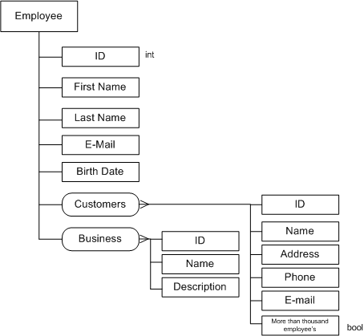

Employee registration data concerns his personal information and spheres of business.

Personal information consists of the following fields:
- ID (integer)
- First Name
- Last Name
- E-Mail
- Birth Date

Each employee may have more than one customer. Customers have the following characteristics:
- ID
- Name – name of the company
- Address
- Phone
- E-mail
- More that thousand employees – Boolean value. It is “true” when the customer company has >1000 employees.

Business is the main business focus area. It has the following properties:
- ID
- Name – Healthcare, Trading, Heavy Machinery, Airlines, Real Estate, etc.
- Description – short description of the business core

Non functional requirements

Technical
- The application is to be based on .Net Windows Forms;
- Data is to be bound to one linked grid; The following Employee data should be shown in the grid: First Name, Last Name, E-Mail, Birth Date as well as their relation to Customers and Business (there should be capability to explore to the Customers and Business (drill-down));
- User should have an ability to add, remove, modify selected items using context menu;
- All data should be stored/loaded to/from xml file using xml-serialization;
- Business fields should be stored in xml as attributes;
- The application should calculate amount of time it took to load/save .xml file. The time should be shown on status bar of the main window;

Student challenge (optional)
You can also implement the following requirements:
  - ID uniqueness checking;
  - E-mail validation.

Architecture
The implementation should follow interface-driven design approach.

Coding
- Comments are required to all classes, methods and parameters using the following pattern
/// <summary>
/// ABC
/// </summary>
/// <param name=" "></param>
...
- Comments are to be written in English;
- Additional comments on key aspects are highly appreciated;
- All the participants are highly advised to follow the Design Guidelines for Class Library Developers http://msdn.microsoft.com/library/default.asp?url=/library/en-us/cpgenref/html/cpconNETFrameworkDesignGuidelines.asp

Web site HTML prototype

Develop an HTML site prototype with the layout as shown on the attached screenshot “Sketch.png”. 
The developed HTML prototype should have the same look when viewed in the following Internet Browsers: Microsoft Internet Explorer 5.5 and up, Netscape Navigator 6.2 and up, Opera 7.0 and up, Mozilla 1.3 and up, Mozilla FireFox.
The web page has to be stretchable (it has to preserve its contents while the form stretches to the sides).

